**Null Space**

**Definition**

Nullspace is the linear subspace of the domain of the map which are mapped to the zero vector. In simpler words, a null space is a subspace of a vector space consisting of vectors that under a given linear transformation are mapped onto zero. It is also known as kernel of linear map.

**Concept**

* The null space of any matrix A consists of all the vectors B such that AB = 0 and B is not zero.
* It can also be thought as the solution obtained from AB = 0 where A is known matrix of size m x n and B is matrix to be found of size n x k.
* The size of the null space of the matrix provides us with the number of linear relations among attributes.

**Geometrical Interpretation**

* Let A matrix be:

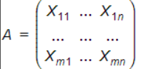

* and B is the vector in the null space of A such that:

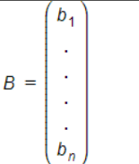

* then B must satisfies the given equations:

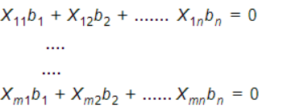

**Examples with Solution**

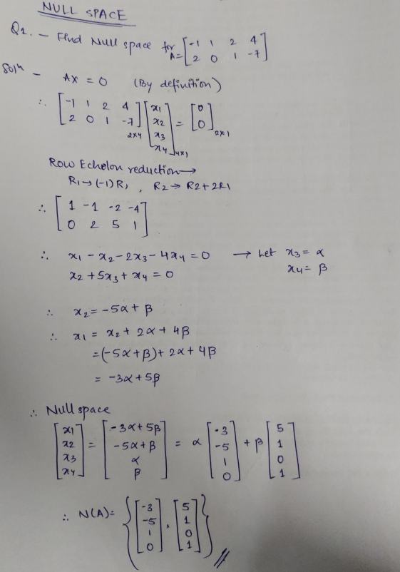

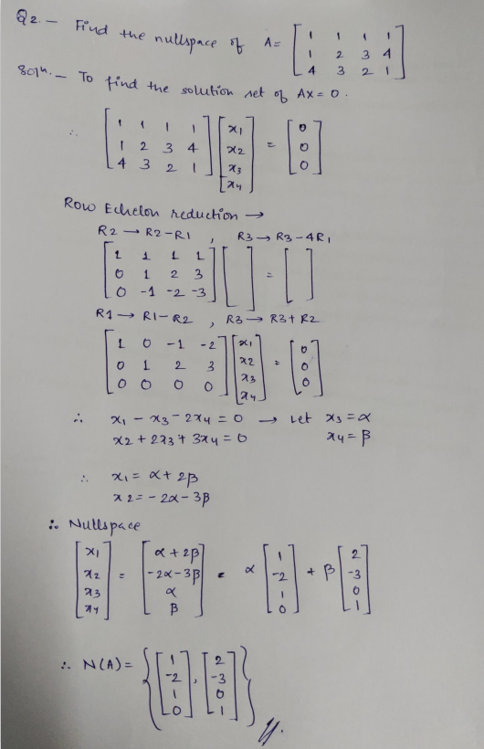

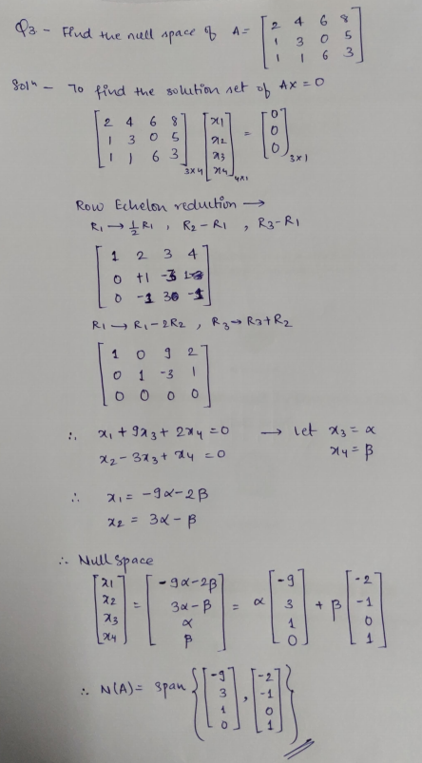

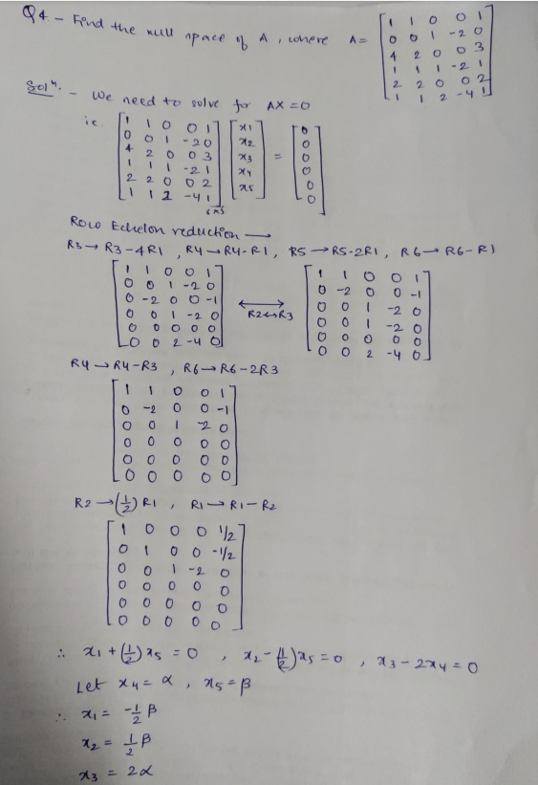

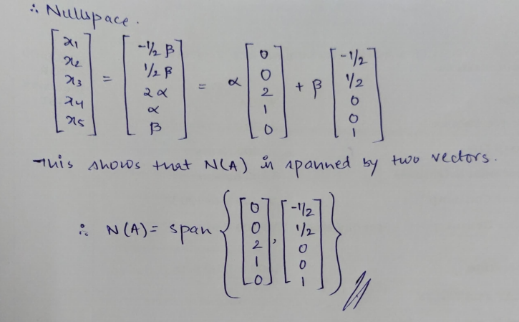

**Procedure**

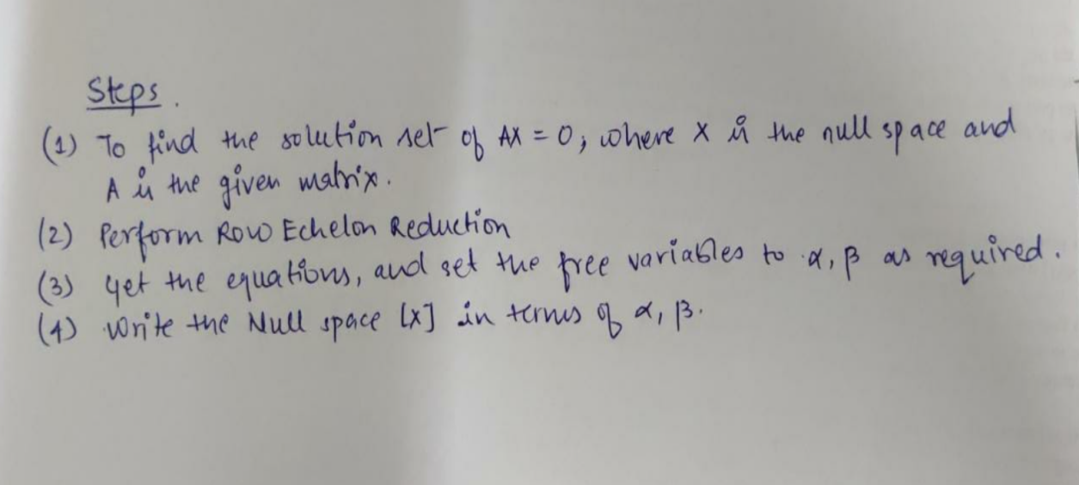

**Applications in real life**

* Room illumination. The range of A represents the area of the room that can be illuminated. The null space of A represents the power we can apply to lamps that don't change the illumination in the room at all.
* A set of map directions at the entrance to a forest. You can apply the directions to different combinations of trails. Some trail combinations will lead you back to the entrance. They are the null space of the map directions.
* Think of an observer and n number of speakers at different distance and in directions. Now make a matrix of equations for sound from each speaker, based on contribution of their amplitude, frequencies and phase. Null space will be formed of all possible combination that you can set in a way that, the total/superimposed sound at observer location will be zero. Means, observer will not hear anything even if the speakers are playing.